***INCOME TAX WEBSITE***

***LINK TREE***

***HOME PAGE***

**CODE:**

***income.php***

<?php session_start();?>

<html>

<head>

<link rel=stylesheet type="text/css" href=button.css >

<link rel=stylesheet type="text/css" href=body.css >

<script>

function contentChange(filename){

var xmlo=new XMLHttpRequest();

xmlo.open("GET",filename+"?_= "+new Date().getTime(),true);

xmlo.onreadystatechange=function(){

if(xmlo.readyState==4)document.getElementById("content").innerHTML=xmlo.responseText;

}

xmlo.send();

if(filename!="home.html")

menu.style.display="block";

}

</script>

<style>

#heading{

width:98%;

overflow:hidden;

height:15%;

background-color:salmon;

color:white;

padding:10px;

padding:20px;

border-radius:10px;

box-shadow: 0 4px 8px 0 rgba(0, 0, 0, 0.2), 0 6px 20px 0 rgba(0, 0, 0, 0.19);

}

#menu{

display:none;

border:none;

}

</style>

</head>

<body onload=contentChange("home.html") style="overflow:auto;">

<div id=heading><h1>INCOME TAX DEPARTMENT</h1><h2>Government of India</H2></div>

<div id=toolbar align=right>

<button>Visitors:<?php

$myfile=fopen("visitorCount.txt","r");

$cnt=intval(fread($myfile,10));

fclose($myfile);

$cnt++;

$myfile2=fopen("visitorCount.txt","w");

fwrite($myfile2,$cnt);

fclose($myfile2);

echo $cnt;

?></button>

<button onclick=window.open("taxcalculator.html","_self") align=right> <?php echo "TAX CALCULATOR";?></button> <button onclick=window.open("incomelogin.php","_self") align=right><?php if(isset($_SESSION['uname']))echo $_SESSION['uname'];else echo "LOGIN";?></button></div>

<div id=menu align=center>

<TABLE cellspacing=3>

<TR>

<TH><button onclick=contentChange("intro.html")> INTRODUCTION</button>

<TH><button onclick=contentChange("history.html")>HISTORY</button>

<TH><button onclick=contentChange("terms.html")>TAX TERMS</button>

<TH><button onclick=contentChange("rates.html")>TAX RATES</button>

<TH><button onclick=contentChange("deduct.html")>TAX DEDUCTION</button>

</TR>

</TABLE>

</div>

<div align=center id=contentdiv>

<p id=content style="white-space:pre-wrap;" align=center>

</p>

</div>

</body>

</html>

***home.php***

<style>

#homemenu{

border:1px none none;

background-color:white;

border-collapse: collapse;

width:100%;

height:100%;

text-align:center;

}

td{

border-right: 1px solid salmon;

width:20%;

background-color:white;

color:grey;

}

</style>

<TABLE id=homemenu align=center>

<TR>

<TD><A onclick=contentChange("intro.html")> INTRODUCTION</a>

<TD><a onclick=contentChange("history.html")>HISTORY</a>

<TD><a onclick=contentChange("terms.html")>TAX TERMS</a>

<TD><a onclick=contentChange("rates.html")>TAX RATES</a>

<TD><a onclick=contentChange("deduct.html")>TAX DEDUCTION</a>

</TR>

</TABLE>

**OUTPUT:**

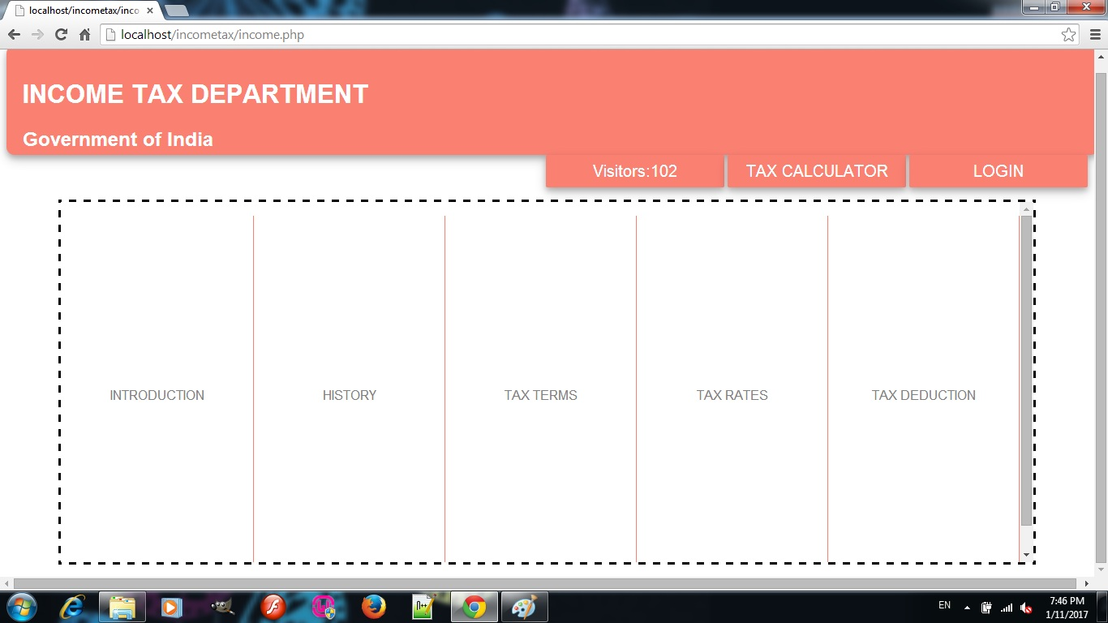

***INTRODUCTION***

**CODE:**

***Intro.html***

<span><h1 align=center>INTRO</h1></span>

<div style="font-size:20px">The government imposes a tax on taxable income of all persons who are individuals, Hindu Undivided Families (HUFs), companies, firms, association of persons, body of individuals, local authority and any other artificial judicial person. Levy of tax is different on each person.Indian Income Tax Act, 1961 levies and governs income tax. The Indian Income Tax Department is administered by CBDT which is part of the Department of Revenue under the Ministry of Finance, Govt. of India. Income tax is a key source of funds that the government uses to fund its activities and serve the public.

The Income Tax Department is the biggest revenue mobilizer for the Government. The total tax revenues of the Central Government increased from ₹1,392.26 billion (US$21 billion) in 1997-98 to ₹5,889.09 billion (US$88 billion) in 2007-08.

An entity whose income exceeds the "maximum amount", which is not chargeable to the income tax, is an assessee, and shall be chargeable to the income tax at the rate or rates prescribed under the finance act for the relevant assessment year, shall be determined on basis of his residential status.

Income tax is a tax payable, at enacted by the Union Budget (Finance Act) for every Assessment Year, on the Total Income earned in the Previous Year by every Person.

</div>

**OUTPUT:**

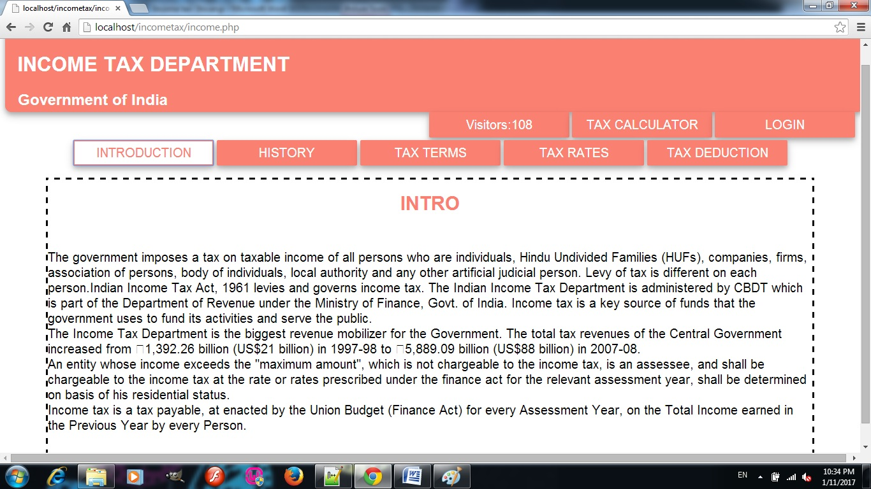

***HISTORY***

**CODE:**

***history.html***

<center><h1><span>INCOME TAX HISTORY</span><h1></center>

"It was only for the good of his subjects that he collected taxes from them, just as the Sun draws moisture from the Earth to give it back a thousand fold" –

--<span>Kalidas in Raghuvansh eulogizing KING DALIP.</span>

It is a matter of general belief that taxes on income and wealth are of recent origin but there is enough evidence to show that taxes on income in some form or the other were levied even in primitive and ancient communities. The origin of the word "Tax" is from "Taxation" which means an estimate. These were levied either on the sale and purchase of merchandise or livestock and were collected in a haphazard manner from time to time. Nearly 2000 years ago, there went out a decree from Ceaser Augustus that all the world should be taxed. In Greece, Germany and Roman Empires, taxes were also levied sometime on the basis of turnover and sometimes on occupations. For many centuries, revenue from taxes went to the Monarch. In Northern England, taxes were levied on land and on moveable property such as the Saladin title in 1188. Later on, these were supplemented by introduction of poll taxes, and indirect taxes known as "Ancient Customs" which were duties on wool, leather and hides. These levies and taxes in various forms and on various commodities and professions were imposed to meet the needs of the Governments to meet their military and civil expenditure and not only to ensure safety to the subjects but also to meet the common needs of the citizens like maintenance of roads, administration of justice and such other functions of the State.

In India, the system of direct taxation as it is known today, has been in force in one form or another even from ancient times. There are references both in Manu Smriti and Arthasastra to a variety of tax measures. Manu, the ancient sage and law-giver stated that the king could levy taxes, according to Sastras. The wise sage advised that taxes should be related to the income and expenditure of the subject. He, however, cautioned the king against excessive taxation and stated that both extremes should be avoided namely either complete absence of taxes or exorbitant taxation. According to him, the king should arrange the collection of taxes in such a manner that the subjects did not feel the pinch of paying taxes. He laid down that traders and artisans should pay 1/5th of their profits in silver and gold, while the agriculturists were to pay 1/6th, 1/8th and 1/10th of their produce depending upon their circumstances. The detailed analysis given by Manu on the subject clearly shows the existence of a well-planned taxation system, even in ancient times. Not only this, taxes were also levied on various classes of people like actors, dancers, singers and even dancing girls. Taxes were paid in the shape of gold-coins, cattle, grains, raw-materials and also by rendering personal service.

**OUPUT:**

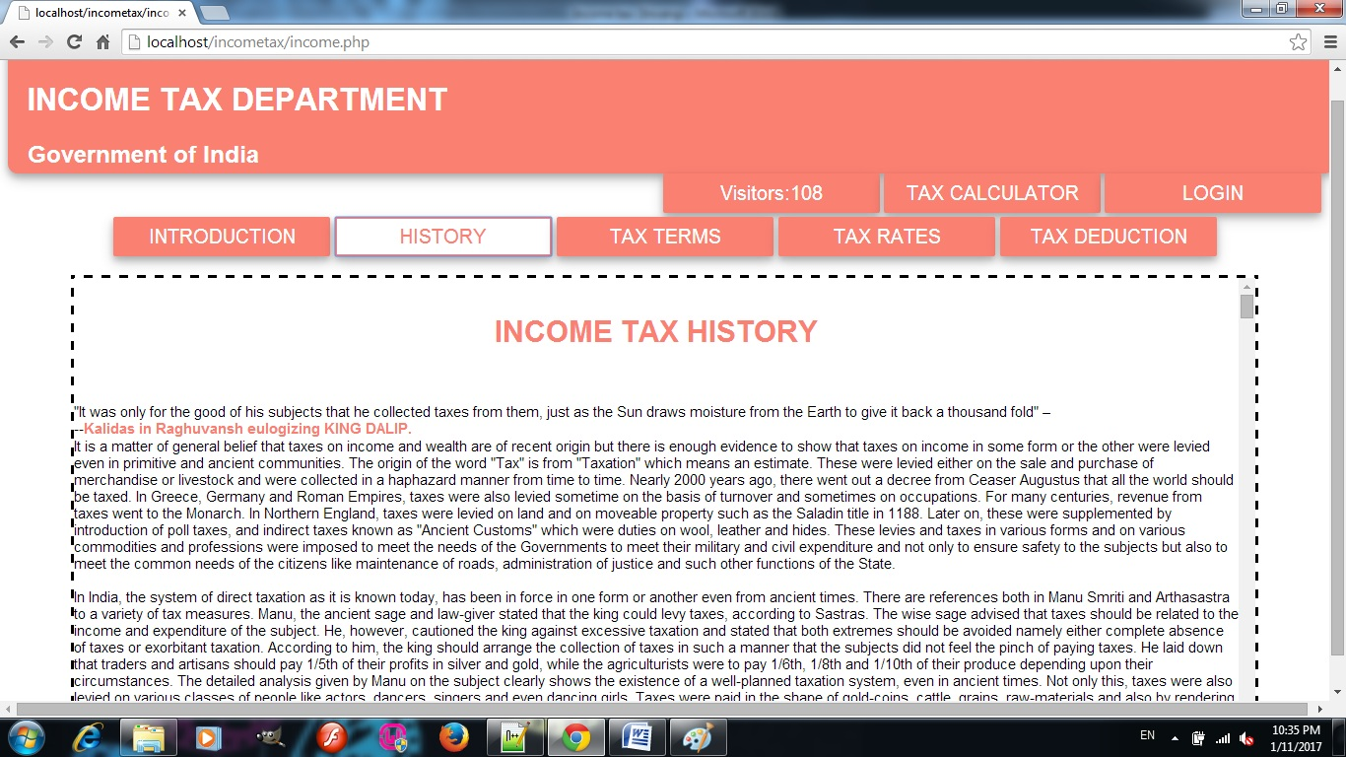

***TAX TERMS***

**CODE:**

***terms.html***

<span><h1 align=center>10 ESSENTIAL TERMS</H1></span>

<span>Financial Year</span>

The financial year is a 12 month period beginning the April1st each year and ending on 31st of March the following year.

For example: You will pay taxes on your earnings during the April 1st 2012 to March 31st 2013 which is referred to as financial year 2012-13.

<span>Assessment Year</span>

The assessment year refers to your income earned in the previous financial year. For example,Assessment Year 2013-14 refers to the income earned in the financial year2012-13.

The Income Tax department in India wants you to assess your income for a financial year ending March 31st each year. Example: As you can only find out the actual total earnings after March 31st2013, the tax department gives you time till July 31st 2013 to assess and file your Tax Return.

<span>PAN number</span>

The Income Tax Department of India identifies you with this number. This is a 10 digit number given by the I-T department to each individual, Business, Firm, Company, in the form of a laminated card (called the PAN card).

Whenever you do a tax related transaction, PAN has to be given. All major financial transactions need you to quote this number.

<span>TAN number</span>

TAN or Tax deduction and collection account number is a 10 digit number given by the tax department to all individuals / companies, who make payments to others.

Whenever a company makes a payment to someone, tax is deducted at the company’s end (tax deduction at source) and put in a government account on behalf of the tax department. The companies that deduct this tax are supposed to have a TAN number identifying them.

<span>TDS</span>

Tax Deducted at Source (TDS) is the amount deducted by a company/Individuals before making a payment to others. This is done as per the Income Tax Act so that the burden of payment of lump-sum tax does not fall upon the individual at the end of the financial year.

TDS on Salary: Tax is deducted at source by the employer before paying the wages and salary to the employees. This information is present in the Form-16. Form-16 is usually issued annually by the company to its employees. Refer to ClearTax’s guide to understanding your Form-16here.

TDS on Non Salary: The tax deducted at source on payments like Rent, Interest Income, Commission, Consultation fees, Freelancer charges,etc (essentially anything other than Salary). These are stated on Form 16A. TheForm-16A has to be issued by the deductor to the deductee in the same quarter in which the deduction is made.

<span>Advance Tax</span>

According to income tax rules, if the tax liability of a taxpayer is more than Rs 10,000 in a financial year and one knows that in advance, one has to pay:

● 30% of the liability by September 15th

● 60% of the liability by 15th December (less advance tax already paid)

● Remaining liability by 15th March (less advance tax already paid) of the financial year.

This is to avoid certain charges levied by the department in case of non-payment of these taxes as per the dates above. The penalty /charges would be levied when you make your return after the end of the financial year, if the advance tax is not paid.

How do you actually pay the Tax that is due? Read here to find out how...

<span>Self-Assessment Tax</span>

An individual / company has to calculate one’s tax liability at the end of the financial year, on the earnings during that year.

The taxpayer self-assesses (or gets the taxes assessed by an authorized expert) to find one’s tax liability after accounting for TDS and advance tax. This is called the self-assessment tax.

Use ClearTax’s Tax Calculator to compute your taxes this year.

<span>Form 16</span>

An employer has to give its employee a form 16 stating:

● The employee’s salary

● The tax deducted at source (TDS)

● Tax paid to the tax department.

If your company issues a Form 16 PDF, you can directlyimport it into ClearTax and begin Tax Filing.

<span>Form 16A</span>

This form reflects TDS deducted on non-salary payments.

TDS deducted on house rents, interest payments etc are stated in the form 16A.

It is issued quarterly, as opposed to Form 16 which is issued usually annually, by the company / bank that pays the rent / interest etc.

<span>Form 26AS</span>

**OUTPUT:**

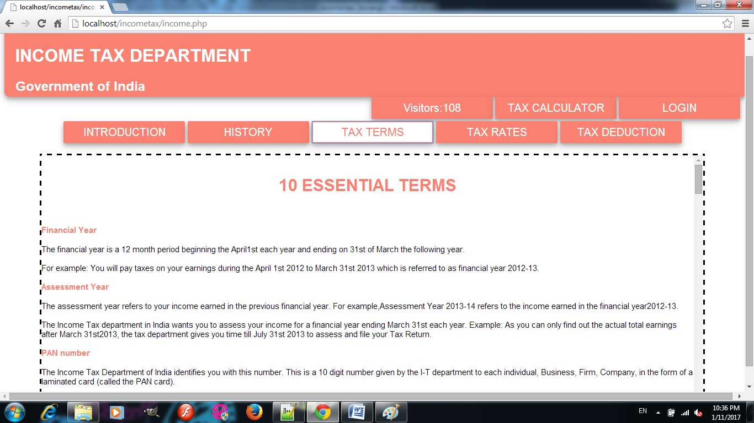

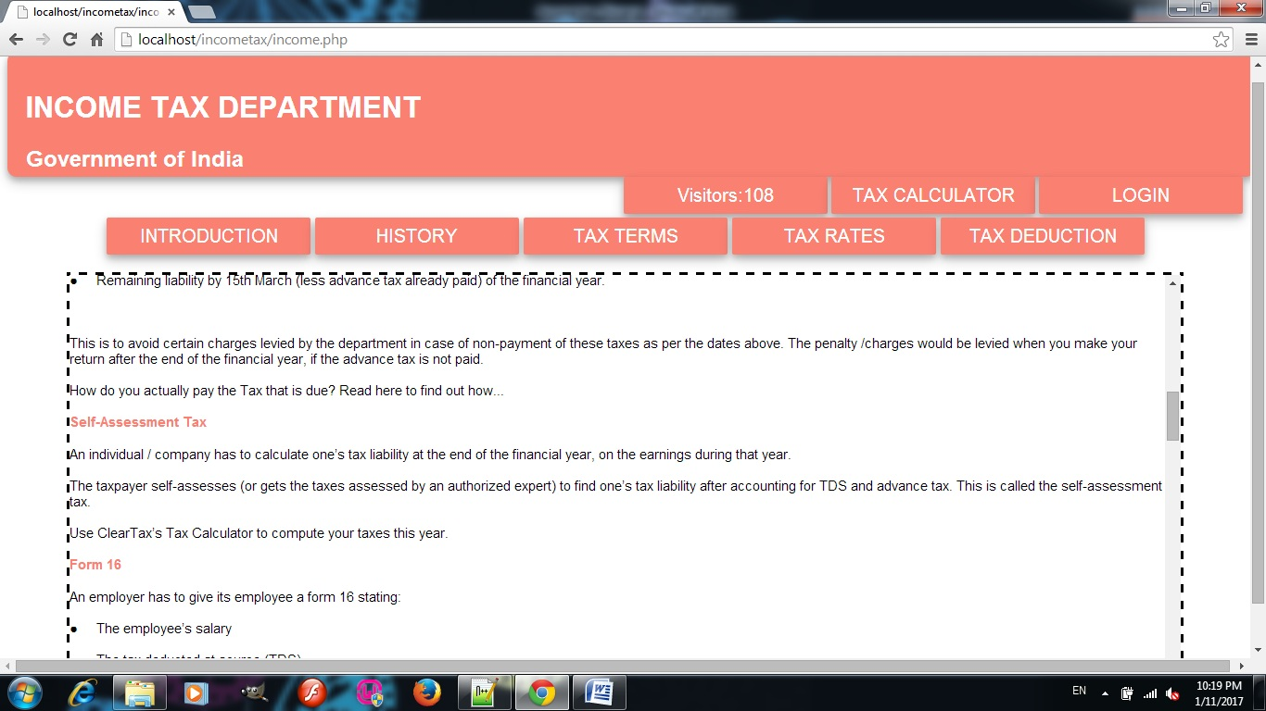

***TAX RATES***

**CODE:**

***rates.html***

<style>

.tablestyle{border:solid salmon;}

.thstyle{background-color:salmon;color:white;}</style>

<span><h1 align=center>For Men Below 60 Years Of Age</h1></span>

<table align=center cellspacing="2" cellpadding="2" class=tablestyle>

<tbody>

<tr class=tablestyle>

<th class=thstyle>Income Tax Slab</th>

<th class=thstyle>Income Tax Rate</th>

</tr>

<tr class=tablestyle>

<td>Income upto Rs. 2,50,000</td>

<td>Nil</td>

</tr>

<tr class=tablestyle>

<td>Income between Rs. 2,50,001 - Rs. 500,000</td>

<td>10% of Income exceeding Rs. 2,50,000</td>

</tr>

<tr class=tablestyle>

<td>Income between Rs. 500,001 - Rs. 10,00,000</td>

<td>20% of Income exceeding Rs. 5,00,000</td>

</tr>

<tr class=tablestyle>

<td>Income above Rs. 10,00,000</td>

<td>30% of Income exceeding Rs. 10,00,000</td>

</tr>

</tbody>

</table>

<br />

<span><h1 align=center>For Women Below 60 Years Of Age</h1></span>

<table align=center cellspacing="2" cellpadding="2" class=tablestyle>

<tbody>

<tr class=tablestyle>

<th class=thstyle>Income Tax Slab</th>

<th class=thstyle>Income Tax Rate</th>

</tr>

<tr class=tablestyle>

<td>Income upto Rs. 2,50,000</td>

<td>Nil</td>

</tr>

<tr class=tablestyle>

<td>Income between Rs. 2,50,001 - Rs. 500,000</td>

<td>10% of Income exceeding Rs. 2,50,000</td>

</tr>

<tr class=tablestyle>

<td>Income between Rs. 500,001 - Rs. 10,00,000</td>

<td>20% of Income exceeding Rs. 5,00,000</td>

</tr>

<tr class=tablestyle>

<td>Income above Rs. 10,00,000</td>

<td>30% of Income exceeding Rs. 10,00,000</td>

</tr>

</tbody>

</table>

<br />

<span><h1 align=center>For Senior Citizens (Age 60 years or more but less than 80 years)</h1></span>

<table align=center cellspacing="2" cellpadding="2" class=tablestyle>

<tbody>

<tr class=tablestyle>

<th class=thstyle>Income Tax Slab</th>

<th class=thstyle>Income Tax Rate</th>

</tr>

<tr class=tablestyle>

<td>Income upto Rs. 3,00,000</td>

<td>Nil</td>

</tr>

<tr class=tablestyle>

<td>Income between Rs. 3,00,001 - Rs. 500,000</td>

<td>10% of Income exceeding Rs. 3,00,000</td>

</tr>

<tr class=tablestyle>

<td>Income between Rs. 500,001 - Rs. 10,00,000</td>

<td>20% of Income exceeding Rs. 5,00,000</td>

</tr>

<tr class=tablestyle>

<td>Income above Rs. 10,00,000</td>

<td>30% of Income exceeding Rs. 10,00,000</td>

</tr>

</tbody>

</table>

<br />

<span><h1 align=center>For Senior Citizens (Age 80 years or more)</h1></span>

<table align=center cellspacing="2" cellpadding="2" class=tablestyle>

<tbody>

<tr class=tablestyle>

<th class=thstyle>Income Tax Slab</th>

<th class=thstyle>Income Tax Rate</th>

</tr>

<tr class=tablestyle>

<td>Income upto Rs. 5,00,000</td>

<td>Nil</td>

</tr>

<tr class=tablestyle>

<td>Income between Rs. 500,001 - Rs. 10,00,000</td>

<td>20% of Income exceeding Rs. 5,00,000</td>

</tr>

<tr class=tablestyle>

<td>Income above Rs. 10,00,000</td>

<td>30% of Income exceeding Rs. 10,00,000</td>

</tr>

</tbody>

</table>

**OUTPUT:**

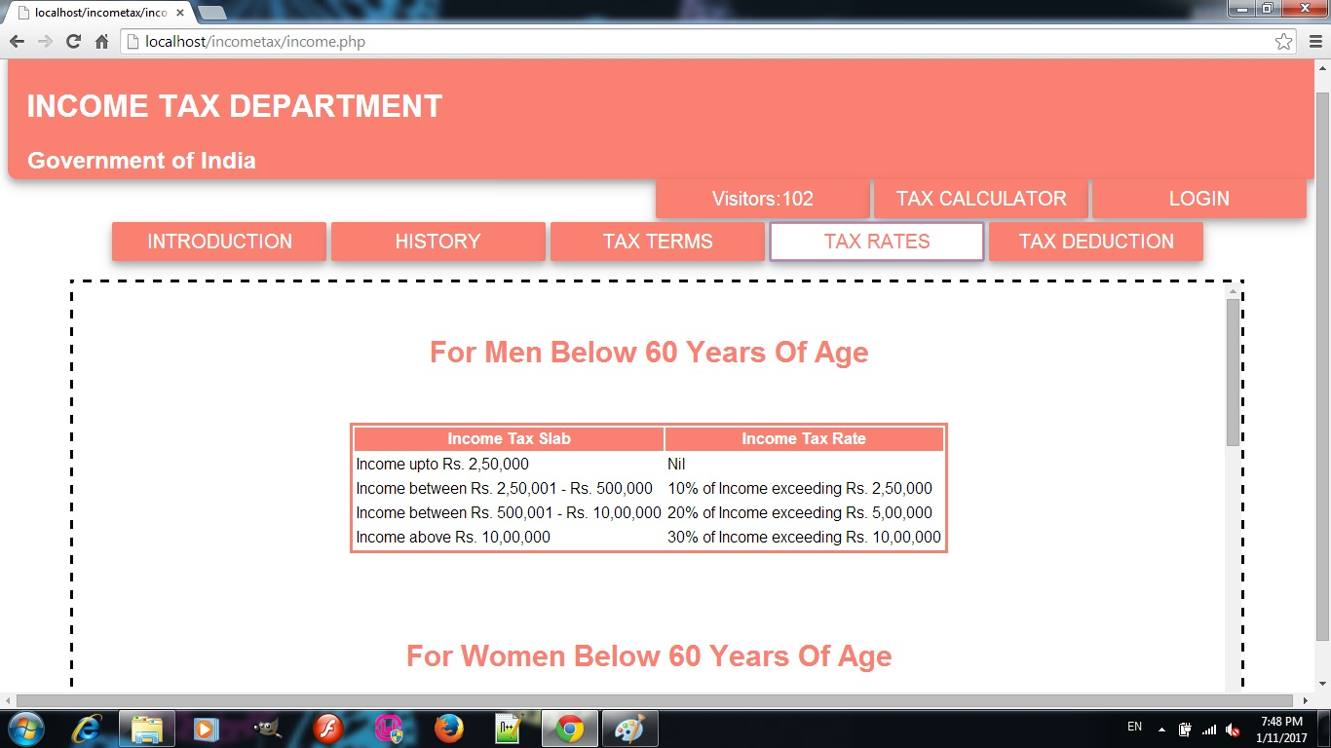

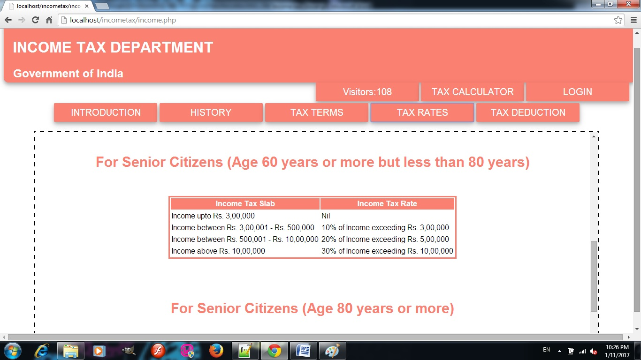

***TAX DEDUCTION***

**CODE:**

***deduct.html***

<span><h1 align=center>TAX DEDUCTION</h1></span>

Tax deduction is a reduction of income that is able to be taxed, and is commonly a result of expenses, particularly those incurred to produce additional income. The difference between deductions, exemptions and credit is that deductions and exemptions both reduce taxable income, while credits reduce tax.

One important aspect of determining tax deductions for business expenses is the timing of such deduction. The method used for this is commonly referred to as an accounting method.

<span>Mode of payment of TDS:</span>

Taxes deducted at source shall be deposited to the credit of the Central Government in following modes:

1) E-Payment: E-Payment is mandatory for :

a) All the corporate assesses.

b) All assesses (other than company) to whom provisions of section 44AB of the Income Tax Act, 1961 are applicable.

Physical Mode: By furnishing the Challan No. 281 in the authorized bank branch

TDS Rate

A deductor is required to deduct tax at source in accordance with the rates as specified in the relevant provision of the Income-tax Act (‘Act’) read with First Schedule to Finance Act. However, if PAN of the recipient is not intimated to the deductor, in view of Section 206AA, tax shall be deducted at source at higher of the following rates:

a) at the rate specified in the relevant provision of this Act; or

b) at the rate or rates in force; or

c) at the rate of 20%.

Further where any person located in a notified jurisdictional area is entitled to receive any sum or income or amount on which tax is subject to TDS, the tax shall be deducted in accordance with at the highest of the following rates:​

a) at the rate or rates in force;

b) at the rate specified in the relevant provisions of this Act;

c) at the rate of 30%

**OUTPUT:**

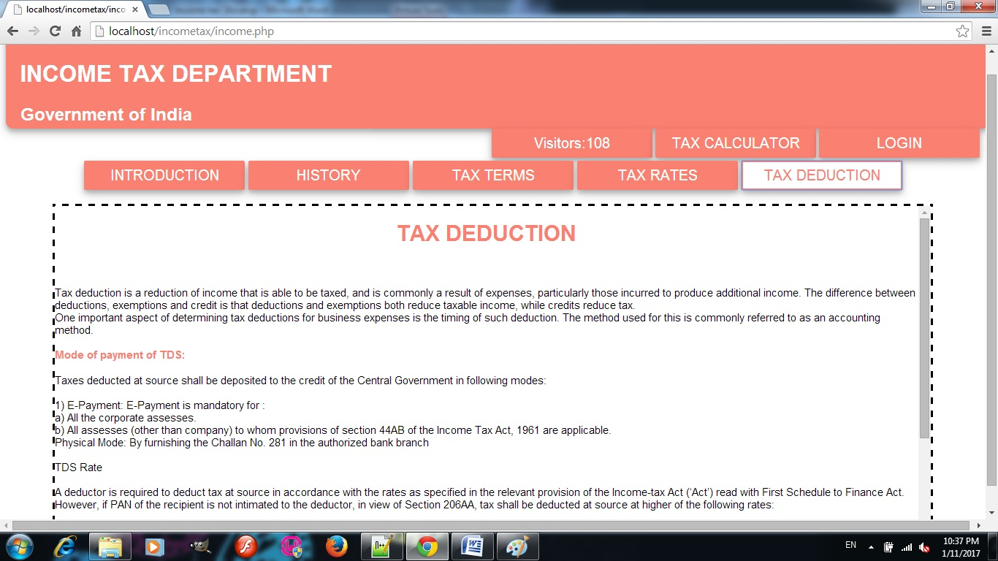

***TAX CALCULATOR***

**CODE:**

***taxcalculator.html***

<HTML>

<head>

<link rel="stylesheet" type="text/css" href="button.css">

<link rel="stylesheet" type="text/css" href="textbox.css">

<style>

table{

width:700px;

height:80%;

font-size:30px;

background-color:white;

text-align:center;

padding:2px;

color:grey;

border-radius:5px;

box-shadow: 0 4px 8px 0 rgba(0, 0, 0, 0.2), 0 6px 20px 0 rgba(0, 0, 0, 0.19); }

th{

color:white;

background-color:salmon;

text-align:center;

border-radius:5px;

}

</style>

<script>

function calculate()

{

var age=parseInt(frm.uage.value);

var inc=parseInt(frm.income.value);

var amount;

if(age<=60) {

if(inc<=250000)

{amount=0;}

else if (inc<=500000)

{amount=(inc-250000)*0.1;}

else if(inc<=1000000)

{amount=25000+((inc-500000)*0.2);}

else

{amount=125000+((inc-1000000)*0.3);}

frm.result.value=amount;

}

if(age>60&&age<80)

{

if(inc<=300000)

{amount=0;}

else if (inc<=500000)

{amount=(inc-300000)*0.1;}

else if(inc<=1000000)

{amount=20000+((inc-500000)*0.2);}

else

{amount=120000+((inc-1000000)*0.3);}

frm.result.value=amount;

}

if(age>=80) {

if(inc<=500000)

{amount=0;}

else if (inc<=1000000)

{amount=(inc-500000)*0.2;}

else

{amount=100000+((inc-1000000)*0.3);}

frm.result.value=amount; } }

</script>

<BODY bgcolor=Lightsalmon>

<FORM name=frm>

<BR><BR><BR>

<TABLE align=center cellspacing=4>

<Thead><th colspan=2 align=center> TAX CALCULATOR</thead>

<FORM>

<TR>

<TD>Choose gender:

<TD><INPUT type="radio" NAME="gen" value="male">Male

<INPUT type="radio" NAME="gen" value="female">Female<BR></TR>

<TR>

<TD> Enter your Age:

<TD> <INPUT type= text name=uage>

</TR>

<TR>

<TD>Net Taxable income:

<TD><input type=text name=income>

</TR>

<TR><TD>So your Tax is

<TD> <input type= text name=result>

</TR>

<TR><TD colspan=2 align=center><Input type=button value=Calculate onClick=calculate()>

</TR></FORM></Table></BODY>

**OUTPUT:**

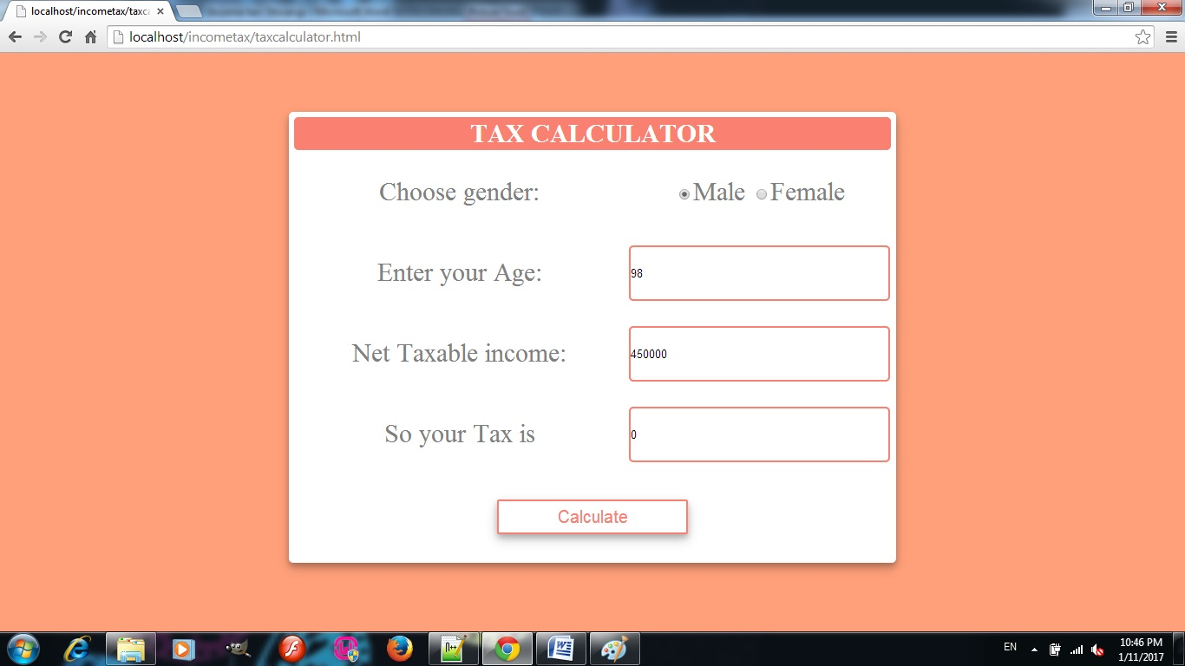

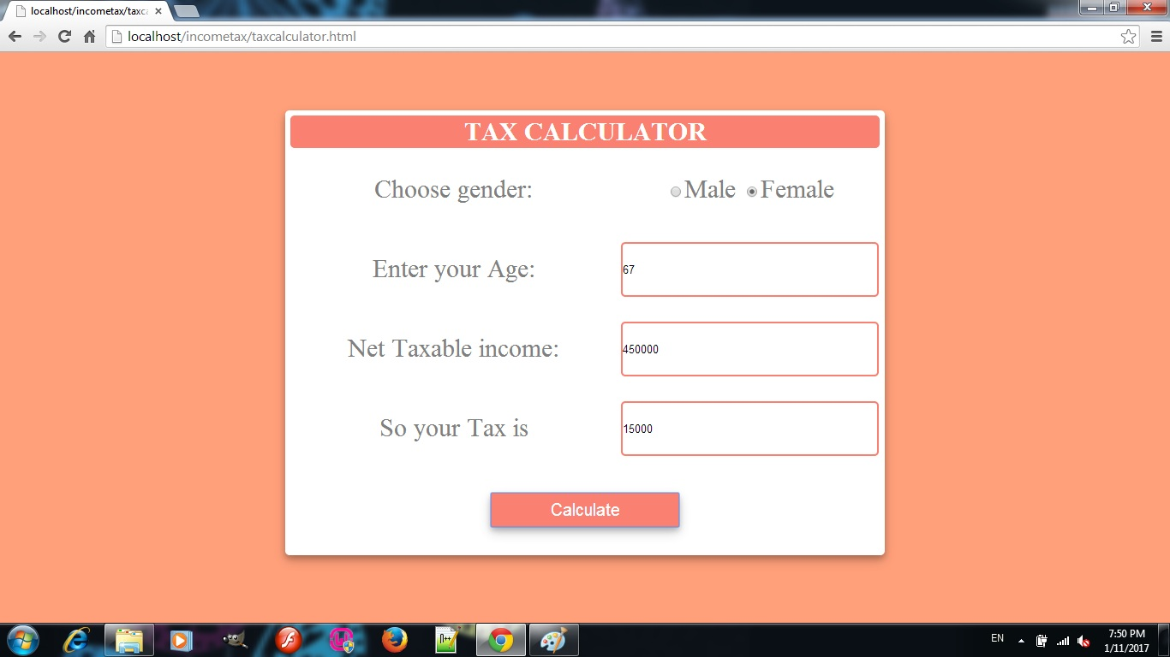

***LOGIN AND CREATE ACCOUNT***

**CODE:**

***incomelogin.php***

<?php

session_start();

$UserName=$_POST['uname'];

$Password=$_POST['upass'];

?>

<html>

<head>

<link rel="stylesheet" type="text/css" href="button.css">

<link rel="stylesheet" type="text/css" href="div.css">

<link rel="stylesheet" type="text/css" href="textbox.css">

<style>

table{

width:700px;

height:80%;

font-size:30px;

background-color:white;

//border-bottom:5px solid grey;

text-align:center;

padding:2px;

color:grey;

border-radius:5px;

box-shadow: 0 4px 8px 0 rgba(0, 0, 0, 0.2), 0 6px 20px 0 rgba(0, 0, 0, 0.19);

}

th{

color:white;

background-color:salmon;

text-align:center;

border-radius:5px;

}

</style>

</head>

<body>

<div id=login align=center>

<form name =frm action=incomelogin.php Method=POST>

<table cellspacing=4>

<tr><th colspan=2>Login Account</tr>

<tr><td>User Name<td><input type=text name=uname id=uname value="<?php echo $UserName;?>"></tr>

<tr><td>Password<td><input type=password name=upass id=upass></tr>

<tr><td><input type=button value="Create New Account " onclick=window.open("incomecreateaccount.php","_self")><td><input type=button value=Login onclick=frm.submit()><td></tr>

<tr><td>

<td>

<?php

include "mysqlconnect.php";

include "CheckAccount.php";

if($UserName!=null){

if($data==null)echo "User doesn't exists!!";

else{

if($Password!=null){

if($data[11]==$Password)

{

$_SESSION['uname']=$UserName;

echo "Logged in as".$_SESSION['uname']."successfully";

header("Location:income.php");

}

else echo "Try Again";

}

else echo "Enter your Password";

}}

?><td>

</tr>

<tr><td colspan=2><a href=UpdatePassword.php>ForgotPassword</a></tr>

</table>

</form>

</form>

</div>

</body>

</html>

***mysqlconnect.php***

<?php

$lnk=mysqli_connect("localhost","shivangi","honey","shivangi");

//$lnk=mysqli_connect("localhost","aniket","aniket","aniket");

if (mysqli_connect_errno())

{

echo "Failed to connect to MySQL: " . mysqli_connect_error();

}

?>

***CheckAccount.php***

<?php

$q="SELECT * FROM loginformdb WHERE username='".$UserName."'";

$re=mysqli_query($lnk,$q);

$data=mysqli_fetch_array($re,MYSQLI_NUM);

?>

***incomecreateaccount.php***

<?php

$Nam=$_POST['uname'];

$Fathername=$_POST['fname'];

$Address=$_POST['add'];

$Gender=$_POST['gen'];

$DOB=$_POST['dob'];

$Blood=$_POST['bg'];

$Mobile=$_POST['mob'];

$Email=$_POST['email'];

$Qual=$_POST['qua'];

$Income=$_POST['inc'];

$UserName=$_POST['cuname'];

$Password=$_POST['cupass'];

$SQuestion=$_POST['sques'];

?>

<html>

<link rel="stylesheet" type="text/css" href="button.css">

<link rel="stylesheet" type="text/css" href="body.css">

<link rel="stylesheet" type="text/css" href="textbox.css">

<style>

div{

border-style:none;

width:100%;

height:100%;

overflow:hidden;

background-color:Lightsalmon;

padding-bottom:30px;

padding-top:1px;

}

table{

width:40%;

height:90%;

font-size:25px;

background-color:white;

text-align:left;

padding:10px;

color:grey;

border-radius:5px;

box-shadow: 0 4px 8px 0 rgba(0, 0, 0, 0.2), 0 6px 20px 0 rgba(0, 0, 0, 0.19); }

th{

color:white;

background-color:salmon;

text-align:center;

border-radius:1px;

box-shadow: 0 4px 8px 0 rgba(0, 0, 0, 0.2), 0 6px 20px 0 rgba(0, 0, 0, 0.19); }

</style>

<body>

<div align=center>

<form name =frm method=POST action=incomecreateaccount.php>

<table>

<tr><th colspan=2>Create account</tr>

<TR><TD>Name:

<TD><INPUT type= "text" NAME="uname" ID="uname"><BR></TR>

<TR><TD>Father's Name:

<TD><INPUT type= "text" NAME="fname" ID="fname"><BR></TR>

<TR><TD>Address:

<TD><INPUT type= "text" NAME="add" ID="add"><BR></TR>

<TR><TD>Gender:

<TD><INPUT type="radio" NAME="gen" value="male">Male

<INPUT type="radio" NAME="gen" value="female">Female<BR></TR>

<TR><TD>Date of Birth:

<TD><INPUT type="date" NAME="dob"><BR></TR>

<TR><TD>Blood Group:

<TD><SELECT NAME="bg">

<OPTION value="A+">A+</OPTION>

<OPTION value="A-">A-</OPTION>

<OPTION value="B+">B+</OPTION>

<OPTION value="B-">B-</OPTION>

<OPTION value="AB+">AB+</OPTION>

<OPTION value="AB-">AB-</OPTION>

<OPTION value="O+">O+</OPTION>

<OPTION value="O-">O-</OPTION>

</Select></TR>

<BR>

<TR><TD>Mobile number:

<TD><INPUT type= "text" NAME="mob" ID="mob"><BR></TR>

<TR><TD>Email ID:

<TD><INPUT type= "text" NAME="email" ID="email"><BR></TR>

<TR><TD>Qualification:

<TD><INPUT type= "text" NAME="qua" ID="qua"><BR></TR>

<BR></TR>

<TR><TD>Income:

<TD><SELECT NAME="inc">

<OPTION value="2,50,000 and below">2,50,000 and below</OPTION>

<OPTION value="2,50,000 to 5,00,000">2,50,000 to 5,00,000</OPTION>

<OPTION value="5,00,000 to 10,00,000">5,00,000 to 10,00,000 </OPTION>

<OPTION value="10,00,000 and above">10,00,000 and above</OPTION>

</Select></TR>

<tr><td>User Name<td><input type=text name=cuname id=cuname value="<?php echo $UserName;?>"></tr>

<tr><td>Password<td><input type=password name=cupass id=cupass></tr>

<tr><td>Security Question<td><input type=text name=sques id=sques PLACEHOLDER="Favourite Book"></tr>

<tr><td><td><input type=submit value=Create></tr>

<tr><td><td>

<?php

include "mysqlconnect.php";

include "CheckAccount.php";

if($UserName!=null && $Password==null && $data==null)echo "Enter your Password";

if($UserName==null && $Password!=null)echo "Enter your User Name";

if($UserName!=null){

if($data!=null)

echo "User Name already taken.<br>Try Again";

else if($data==null && $Password!=null){

$q="INSERT INTO loginformdb VALUES('".$Nam."','".$Fathername."','".$Address."','".$Gender."','".$DOB."','".$Blood."','".$Mobile."','".$Email."','".$Qual."','".$Income."','".$UserName."','".$Password."','".$SQuestion."')";

mysqli_query($lnk,$q);

echo "Your User Name is:";

echo $UserName;

echo "<br><a href=incomelogin.php>GO TO LOGIN PAGE</a>";

}

}else if($Password==null)echo "Enter the fields";

?></tr></table></form></div></body></html>

**OUTPUT:**

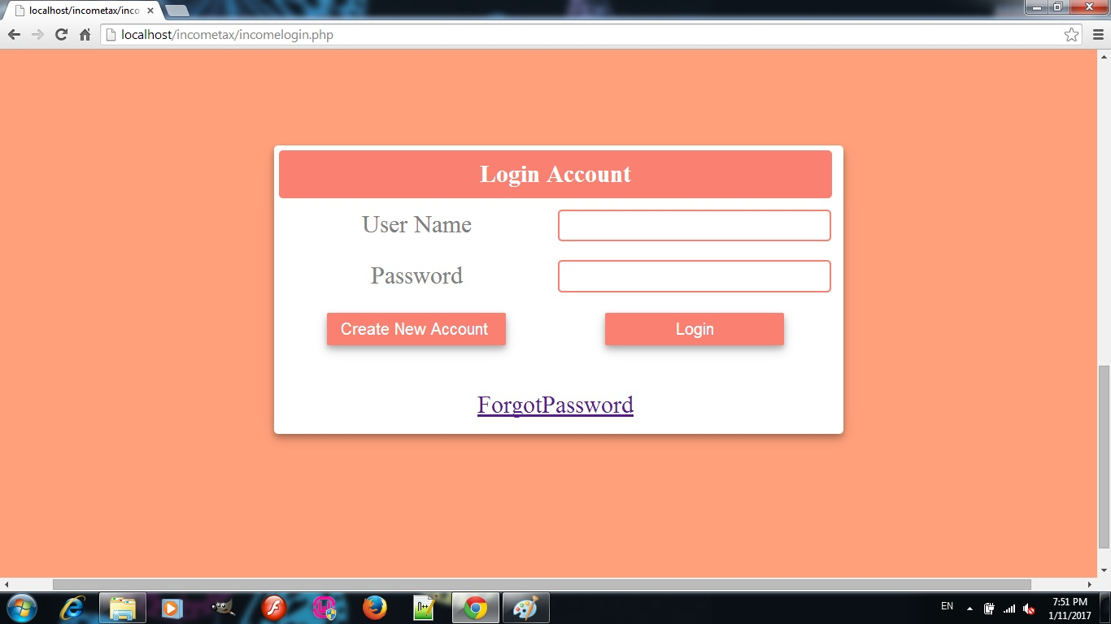

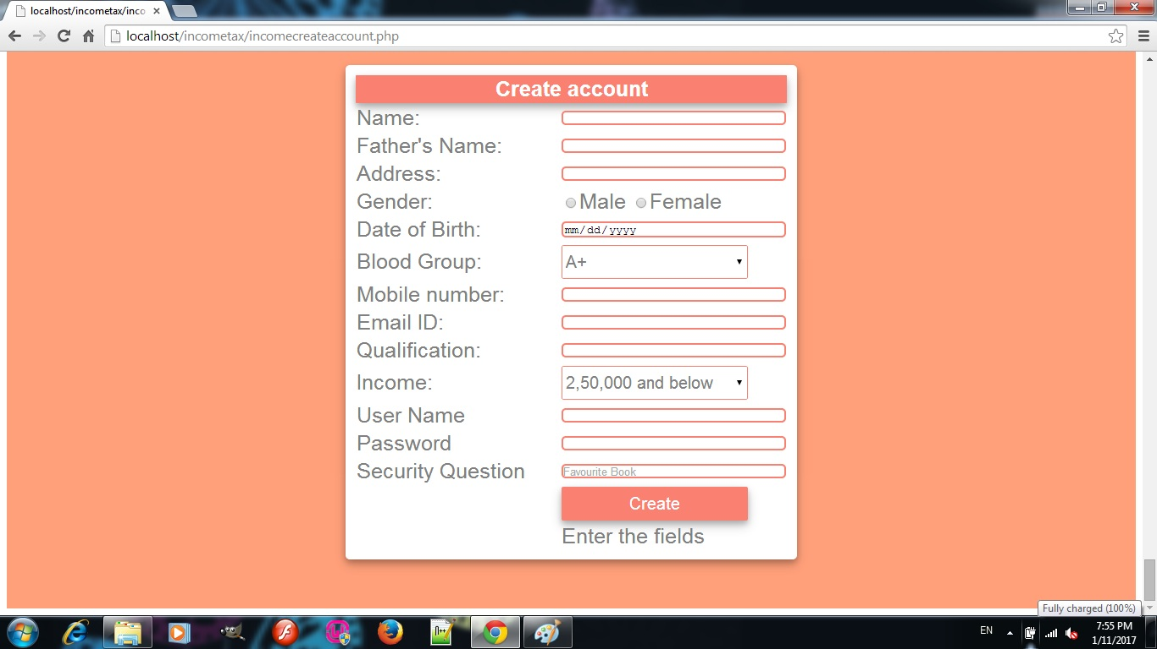

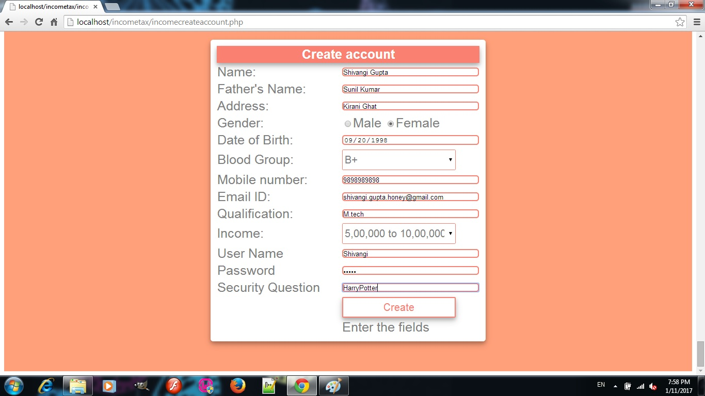

**User name already taken case:**

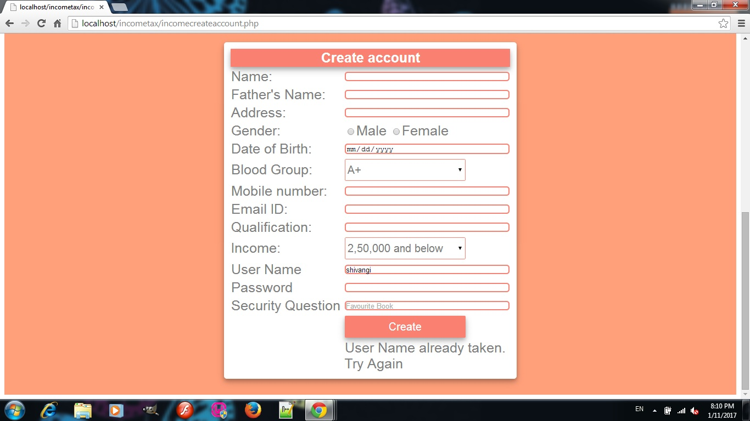

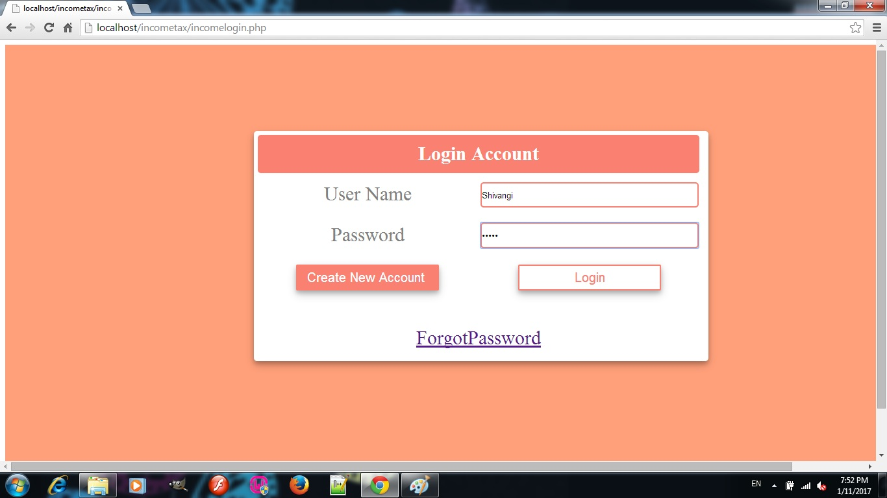

**WRONG PASSWORD :**

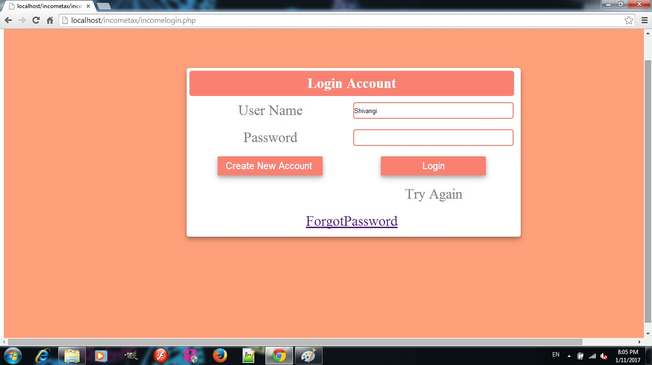

**LOGGED IN:**

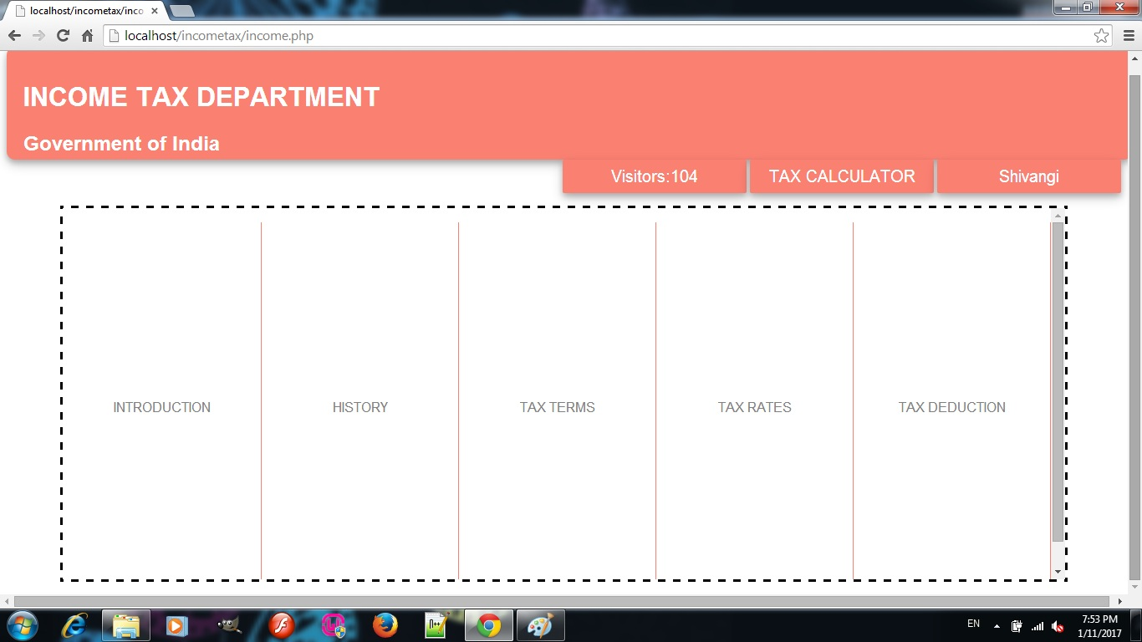

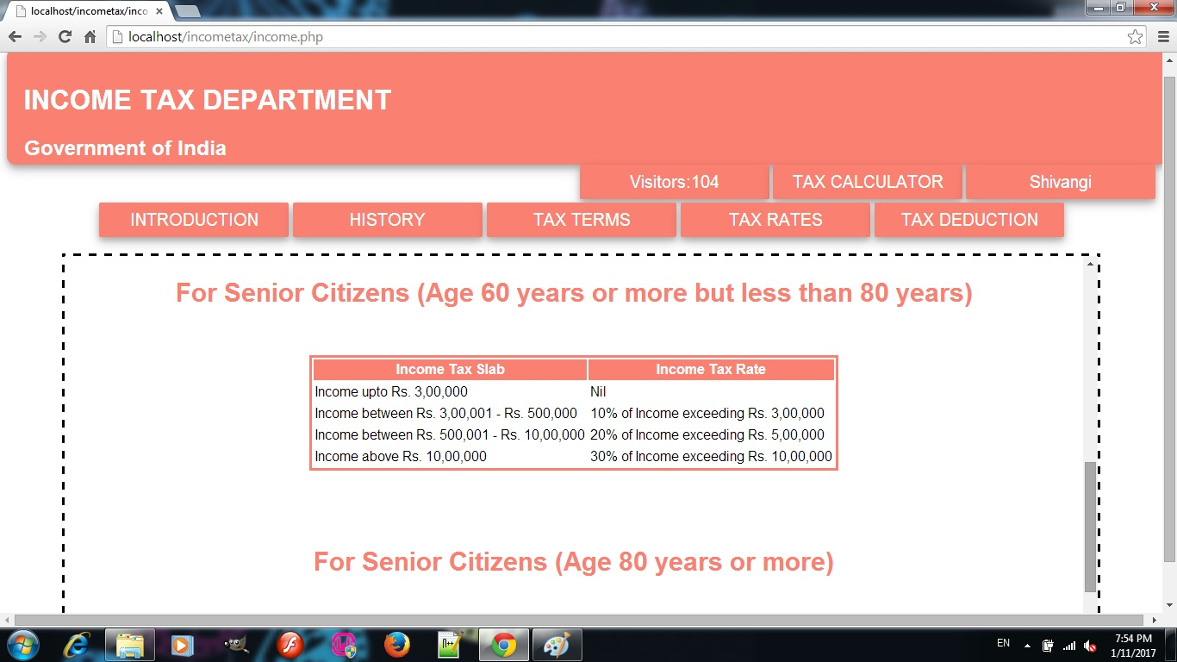

**DATABASE:**

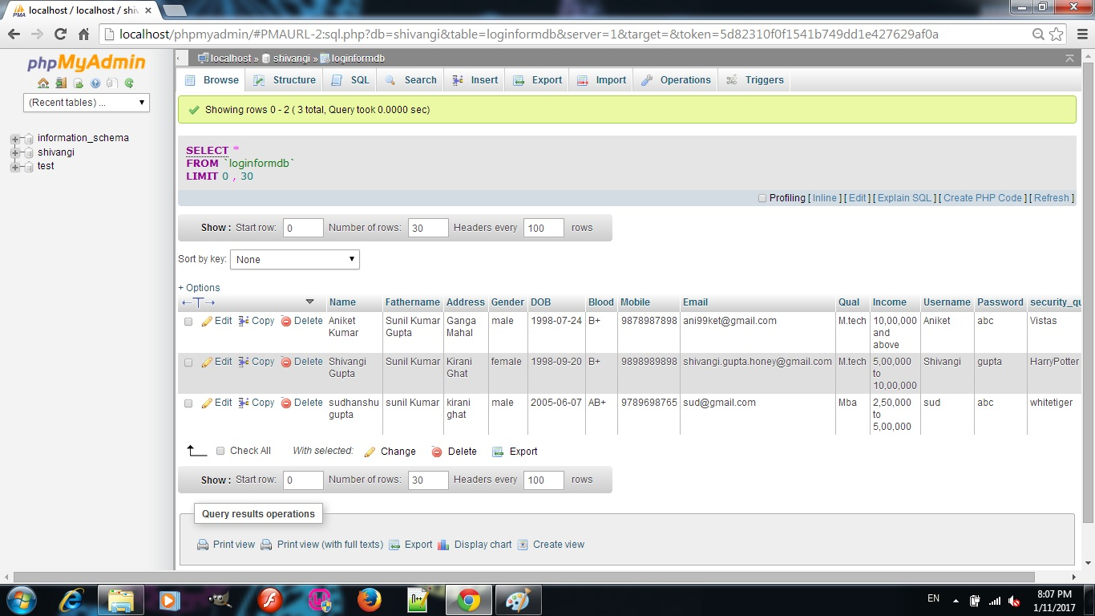

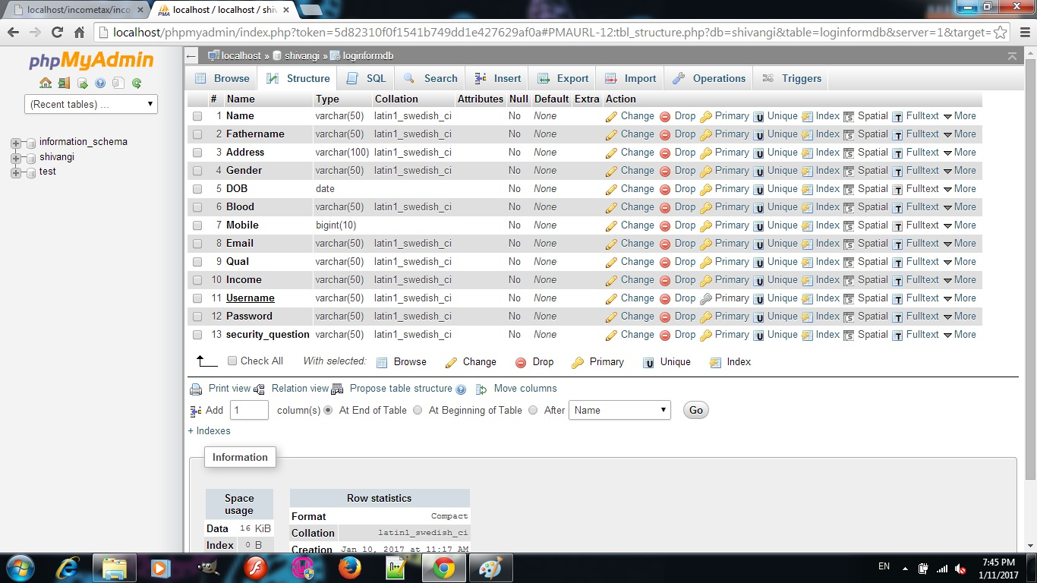

***RESET PASSWORD***

**CODE:**

***UpdatePassword.php***

<?php

$UserName=$_POST['uname'];

$Password=$_POST['upass'];

$SQuestion=$_POST['sques'];

?>

<html>

<head>

<script>

</script>

<link rel="stylesheet" type="text/css" href="button.css">

<link rel="stylesheet" type="text/css" href="div.css">

<link rel="stylesheet" type="text/css" href="textbox.css">

<style>

body{overflow:hidden;}

table{

width:700px;

height:80%;

font-size:30px;

background-color:white;

//border-bottom:5px solid grey;

text-align:center;

padding:2px;

color:grey;

border-radius:5px;

box-shadow: 0 4px 8px 0 rgba(0, 0, 0, 0.2), 0 6px 20px 0 rgba(0, 0, 0, 0.19);

}

th{

color:white;

background-color:salmon;

text-align:center;

border-radius:5px;

}

</style>

</head>

<body>

<div id=login align=center>

<form name =frm action=UpdatePassword.php Method=POST>

<table cellspacing=4 >

<tr><th colspan=2>Reset Password</tr>

<tr><td>User Name<td><input type=text name=uname id=uname value="<?php echo $UserName;?>"></tr>

<tr><td>Security Question<td><input type=text name=sques id=sques PLACEHOLDER="Favourite Book"></tr>

<tr><td>New Password<td><input type=password name=upass id=upass></tr>

<tr><td><input type=button value="Back to login" onclick=window.open("incomelogin.php","_self")><td><input type=button value=Reset onclick=frm.submit()></tr>

<tr><td>

<td>

<?php

include "mysqlconnect.php";

$q="SELECT * FROM loginformdb WHERE Username='".$UserName."' AND security_question='".$SQuestion."'";

$re=mysqli_query($lnk,$q);

$data=mysqli_fetch_array($re,MYSQLI_NUM);

if($UserName!=null && $SQuestion!=null){

if($data==null)echo "Security answers didnt match";

else{

if($Password!=null){

$query2="Update loginformdb SET Password='".$Password."' WHERE Username='".$UserName."' AND security_question='".$SQuestion."'";

mysqli_query($lnk,$query2);

echo "Password reset sucessfully";

}

else echo "Enter your Password";

}}

?><td>

</tr>

</table>

</form>

</form>

</div>

</body>

</html>

**OUTPUT:**

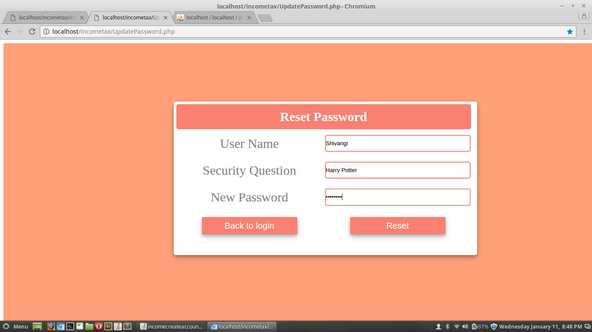

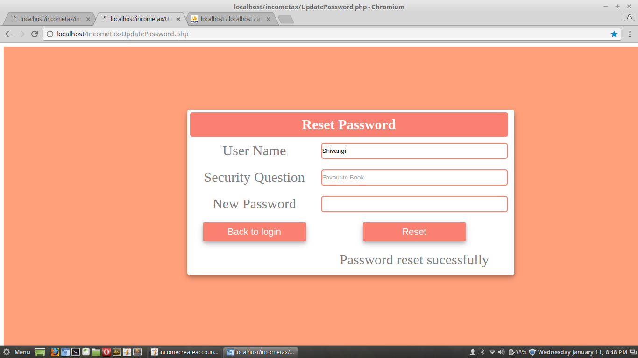

**When Security Question Doesn’t Match:**

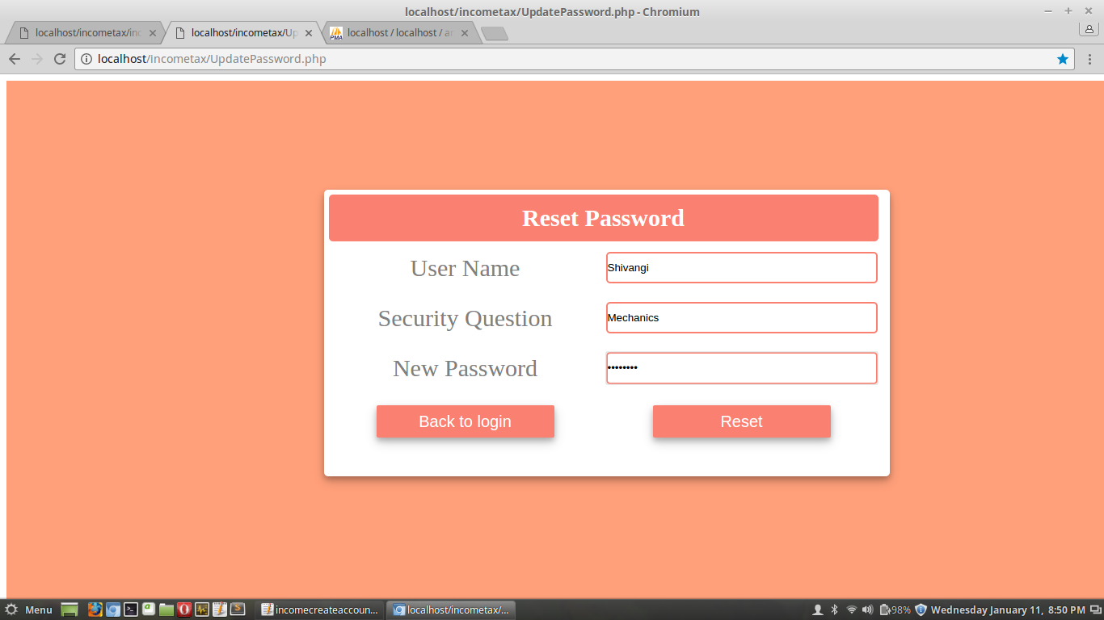

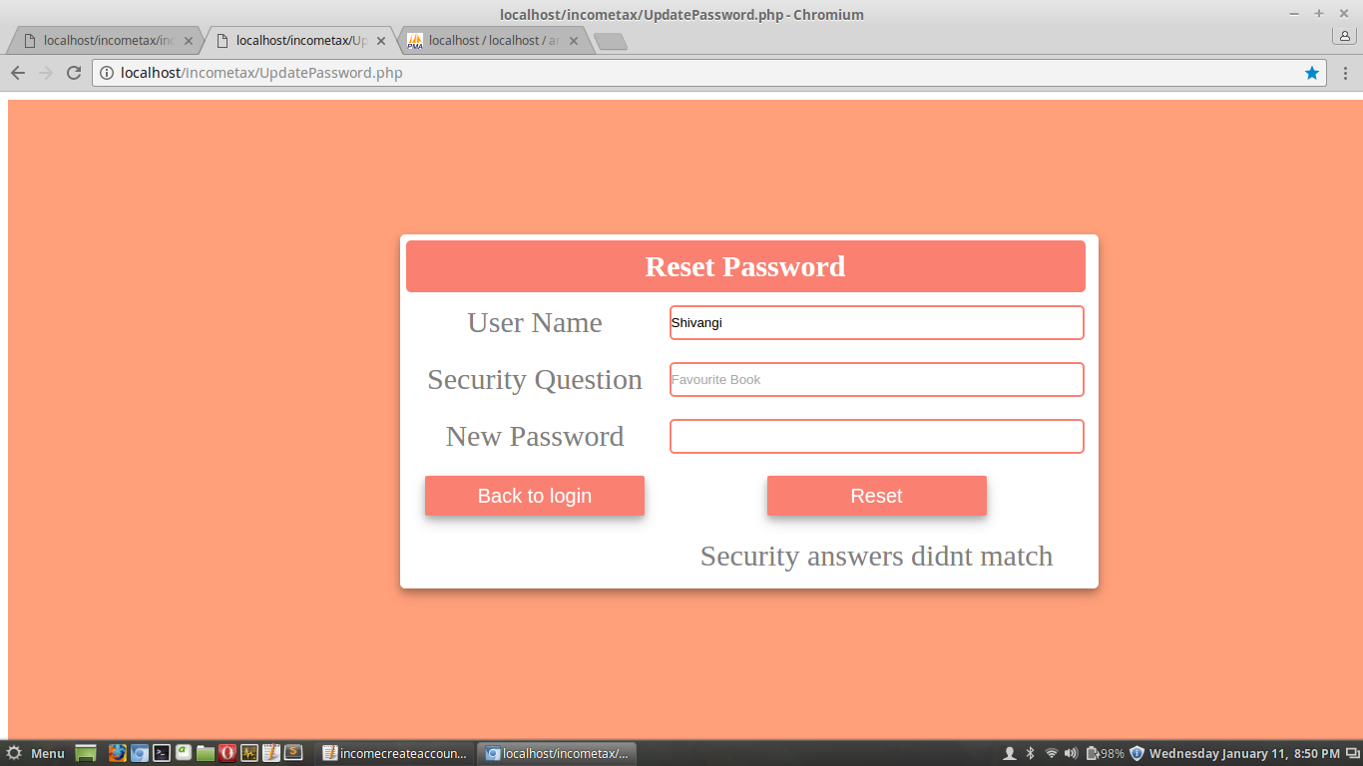

***CSS EXTERNAL STYLE SHEETS***

**CODE:**

***body.css***

body{

background-color:white;

font-family:arial;

}

span{

color:salmon;

font-weight:bold;

}

p{

text-align:justify;

width:90%;

height:70%;

font-size:15px;

background-color:white;

overflow:auto;

border-style:dashed;

}

***textbox.css***

input[type=date],input[type=text],input[type=password]{

border-style:solid;

border-color:salmon;

background-color:white;

border-radius:5px;

width:100%;

height:80%;

}

***table.css***

table{

width:100%;

border-bottom-style:solid;

color:white;

}

th,td{

width:20%;

border:1px solid salmon;

background-color:salmon;

}

th:hover{

width:20%;

border:1px solid salmon;

background-color:white;

color:grey;

}

***div.css***

div{

border-style:none;

width:90%;

height:70%;

padding:10%;

background-color:Lightsalmon;

}

***button.css***

button,input[type=button],input[type=submit]{

border-style:none;

border-radius:2px;

height:40px;

width:220px;

color:white;

font-size:20px;

background-color:salmon;

box-shadow: 0 4px 8px 0 rgba(0, 0, 0, 0.2), 0 6px 20px 0 rgba(0, 0, 0, 0.19);

}

button:hover,input[type=button]:hover,input[type=submit]:hover{

border-style:solid;

border-color:salmon;

border-radius:2px;

height:40px;

width:220px;

color:salmon;

font-size:20px;

background-color:white;}

select{

border:1px solid salmon;

border-radius:2px;

height:40px;

width:220px;

color:grey;

font-size:20px;

background-color:white;